A night of literacy and learning for the entire family
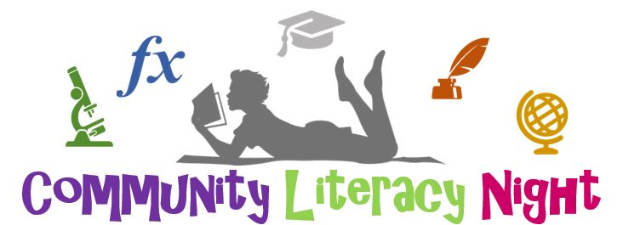
at
Generation Church
365 East 156th St. Cleveland, Ohio 44110

March 9th – April 6th – May 11th – June 8th
7-8pm

Primary (Gr.K-3) – Bible Story Time
Intermediate (Gr. 4-6) – Homework Help
Secondary (Gr. 7-12) - Science OGT/OST Tutoring
Adult – “How to help your child with school”

www.generationchurchcle.org
tolcogic@gmail.com

